January 22nd, 2012
Hi



KUNG HEI FAT CHOI

Quite a number of things have happened this week, though that doesn't necessarily mean that the letter will be any longer.
Today is Chinese New Year's eve. This year will be the year of the dragon - my year! Public holidays last from today till Wednesday. This year HK is doing something that has not been done for many, many years, and that is to set up large temporary bamboo structures in which Cantonese Opera is performed. I remember how these used to be set up every year in different parts of the territory and I even went once, though I don't think it appealed to me much. The government is to allow live poultry and poultry products from China back into HK from today, just in time for new year celebrations. The previous relaxation I mentioned last(?) week only applied to poultry from HK farms. The weather for this Chinese New Year will be quite cold.
In HK, it was announced that last year, there were only 59 'good' days in terms of air pollution. 'Good' is my word; I can't remember how they actually defined it. That is less than two months of breathable air. It was also reported that about 7000 extra people have died as as a result of the high levels of air pollution since Donald Tsang became CE. So in some ways it is strange that it does not seem to be affecting me much as I still have not needed any asthma medication for a long time. However, it does have an effect on young children.
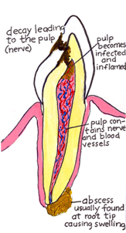
I have had a loose upper tooth and the other night it began causing a lot of pain. So the next morning I went to the (CUHK) dentist for emergency treatment and was there for two hours. I need another three more appointments for this one tooth! What happened, as far as I can understand, is that the root canal in the tooth became infected and all the pus formed due to the inflammation was pushing upwards into the gum area. The dentist had to insert a thin tube into the root canal to drain out the pus and then filled it with antibiotics and a temporary filling. This one tooth is going to cost a packet. I have to pay at the end of the four treatments though I did have to pay for an X-ray which cost $108. Here is a website about root canal treatment (with the picture shown, though the tooth here is a lower tooth):
http://www.dentalfearcentral.org/faq/root-canal/
Things are not going too well between HK and the mainland. There is still a lot of fury about mainland mothers who are still coming to HK to give birth. The government keeps saying it will do something but nothing much seems to happen. The main reason for them coming is that the children born here get right-of-abode and many here believe that unless that is changed, the problem will not be solved. Then there was the report of a professor in China who called HK people 'dogs', increasing the negative feelings between people here and those in the mainland.
I mentioned the problem of Legionnaire's disease bacteria at the new government headquarters. Well, now its toxic gases that are way above safety levels being emitted by construction material and probably new furniture, which some legislators even suspect of being made from sub-standard materials.
Also in HK, a 14-year old girl died of scarlet fever; it seems she became infected at school. And a 12-year old boy is in intensive care with the same disease. Scarlet fever is normally associated with much younger children. It is caused by a bacterium and is also one of those diseases showing resistance to antibiotics.
Every day we are getting more reports about the Italian cruise liner than ran aground and capsized off the Tuscany coast. Shangri-la hotels announced that it is to stop using shark's fin, blue tuna and other endangered sea life in all its restaurants around the world. The message is slowly getting through.
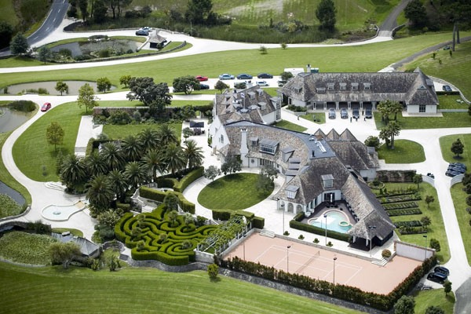
You will have heard about 'Megauplaod' being closed down. I had never heard of the company. It is a HK-registered company with its headquarters in in NZ!! Why they chose NZ I don't know. The guy who set up the company is a German and a HK resident! which means he has a HK ID card (but probably not a permanent ID card unless he was here for seven years). His name is Kim Dotcom - yes, true though be changed his birth family name to this! As well as the raids in NZ, there were also raids here. (The picture shows his house north-east of Auckland, one of the most expensive in the country!)
The run yesterday was the same as for this week last year, from Tai Mei Tuk up and along Baat Sin Leng and on eventually to Tai Po station (and including the section where the wild pig chased me many years ago). It took 2h 56 min, which was 2 minutes slower than last year. I decided to go a little slower at first to have something left at the end. Halfway through I was about 3 minutes behind earlier times but didn't reduce that by much. Still the last 30 minutes was good with almost continuous running instead of the usual stop and start that happens in longer runs.
That’s about it for now.
Cheers

